|  |
| --- |
| DHCP server: installation and configuration on Windows Server - RDR-IT |
| DHCP Server  Install and configuration |
| |  |  |  | | --- | --- | --- | |  |  | User Manual | |

Table of Contents

1. Introduction 2

2. Requirements 2

3. Installing and configuring DHCP Server 2

a. Add Roles and Features 2

b. Role Based or Feature based installation 2

c. Choose Host 3

d. Select Server Roles 3

e. Add Features 4

f. DHCP Server 4

g. Confirm Selections 4

h. Post-deployment Config 5

i. Configuring DHCP Server 6

j. New Scope 7

k. Name your Scope 7

l. Input desired IP Address range 8

m. Set any IPs You would wish to exclude here 8

n. Lease Duration 9

o. DHCP Options 9

p. Input the Default Gateway of the Subnet you gave 9

q. Key in DNS and Domain Name in your environment 10

r. WINS Server (Optional) 10

s. Activate Scope 11

t. Finish Scope Configuration 11

u. Confirm your scope is existing as configured 11

4. Configure Windows Client to Obtain IP from DHCP Server 12

a. Same Network 12

b. Network Settings 12

c. Command Prompt 14

d. Confirm Leases from DHCP Server 15

## Introduction

Having a DHCP Server in your organization can really make your network management a breeze. Instead of assigning IP addresses manually on every machine in your organization, let a DHCP Server do this task that can get quite boring and unnecessarily repetitive. In this guide, it will be shown how DHCP server could be installed and configured in the new Windows Server 2019.

## Requirements

Minimum system specifications to run DHCP server:

* Operating system: Microsoft Windows XP / Vista / 7 / Server 2003 / Server 2008 or higher
* Processor: Pentium or equivalent or higher
* Ram: 32MB minimum
* Disk space: 5MB minimum

Additionally, we will follow this documentation:

* <https://computingforgeeks.com/how-to-install-and-configure-dhcp-server-on-windows-server/>

to properly implement the service to our architecture

## Installing and configuring DHCP Server

### Add Roles and Features

On your “Server Manager” window, click on “Add Roles and Features“. This will bring up a pop-up window. Click “Next” on that pop-up

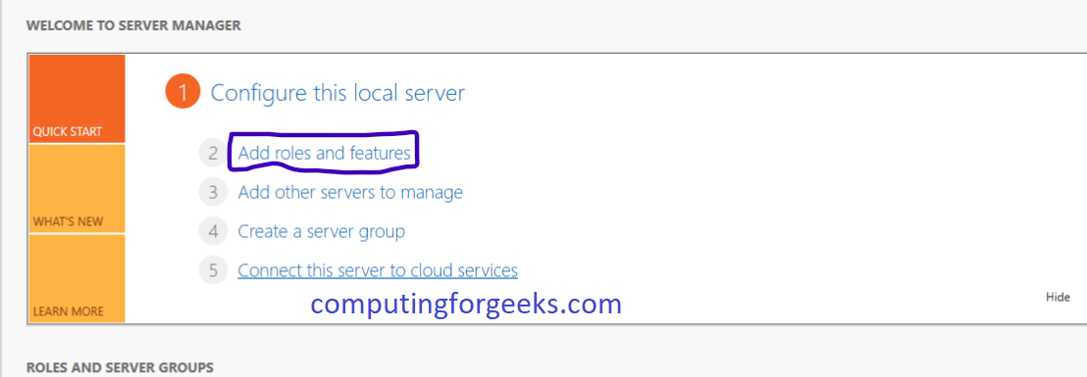

### Role Based or Feature based installation

On this page, choose the “Role Based or Feature based installation” radio option and hit “Next“.

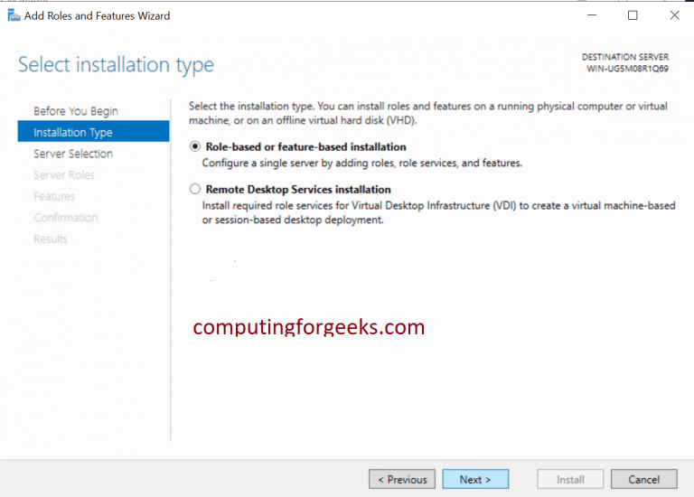

### Choose Host

On this page, choose the server you would wish to install the DHCP Server on. On this guide, we are choosing the local server. Click “Next” after that.

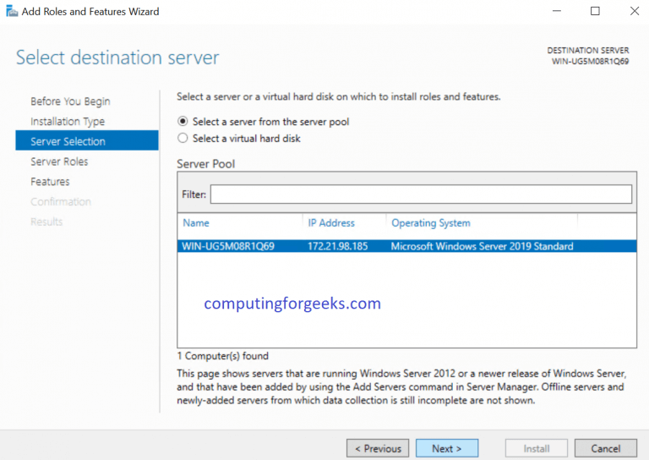

### Select Server Roles

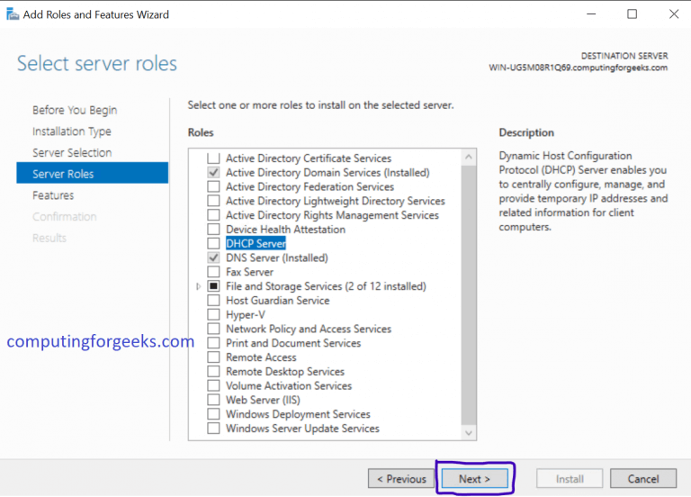This next page is titled “Select Server Roles” and has got a list of roles to install. As you can guess, we are going to choose “DHCP Server“. Please go ahead and choose it.

### Add Features

After you choose “DHCP Server” on the previous step, another pop-up window will come up titled “Add features that are required for DHCP Server?“. Simply click on “Add Features“. Click on “Next” after that.

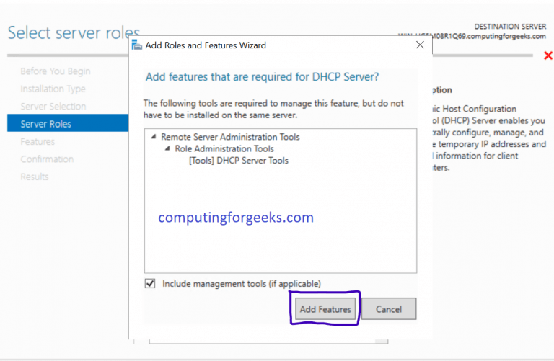

### DHCP Server

On the next page titled “DHCP Server” simply click on “Next“.

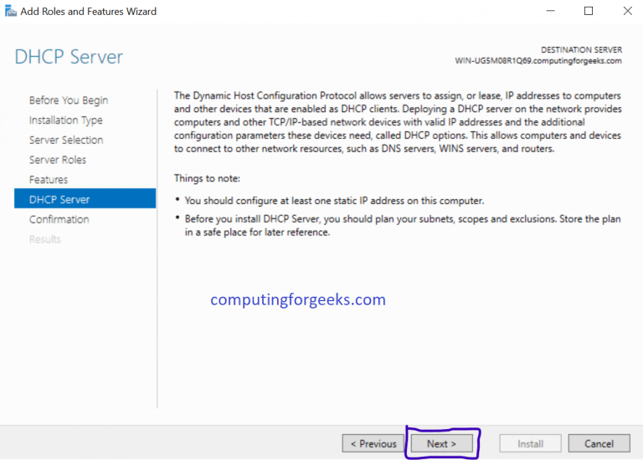

### Confirm Selections

The next page is titled “Confirm installation selections“. Look at the list provided and confirm that DHCP Server and others are listed. After that, click “Install“. After everything is successfully installed, click “Close” and your DHCP Server is installed. Let us proceed to do Post-deployment Configuration on the DHCP.

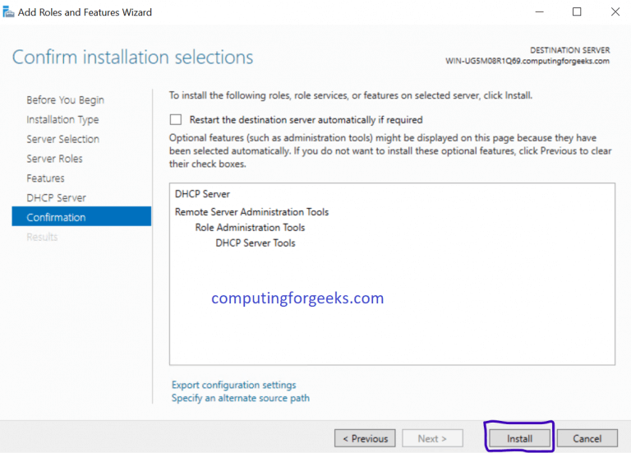

### Post-deployment Config

a new window with the title “All Server Task Details and Notifications” will come up. Below it, you will see “Post-deployment Configuration” line. Click on “Complete DHCP Configuration” at the end of that line as shown below. An installation wizard will come up. Click “Next“

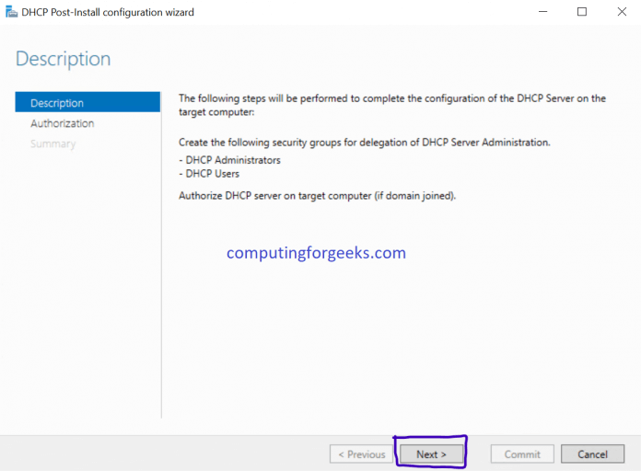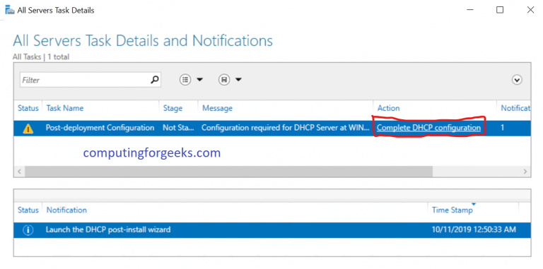

On this page of the Wizard, you are presented with three options. You can proceed with the Administrator’s credentials, an alternate user’s credentials and also AD Authorization. If your server is standalone and is not in any Active Directory Domain, then choose “Skip AD authorization” radio. If it is then you will use the credentials as recorded in your AD. After you make the decision that befits your environment, click “Commit“. Let it finish its thing and if is successful, delightfully click on “Close“.

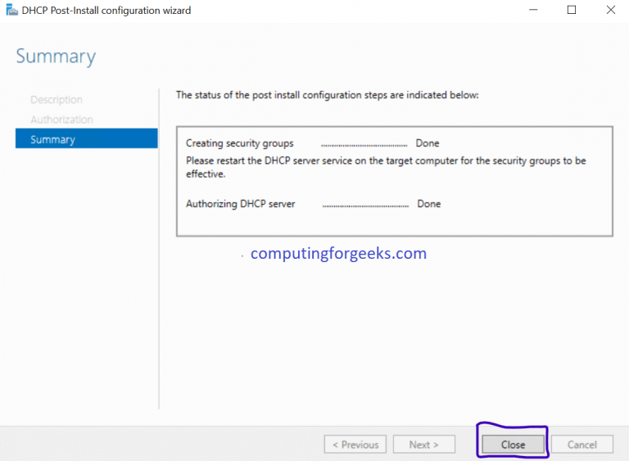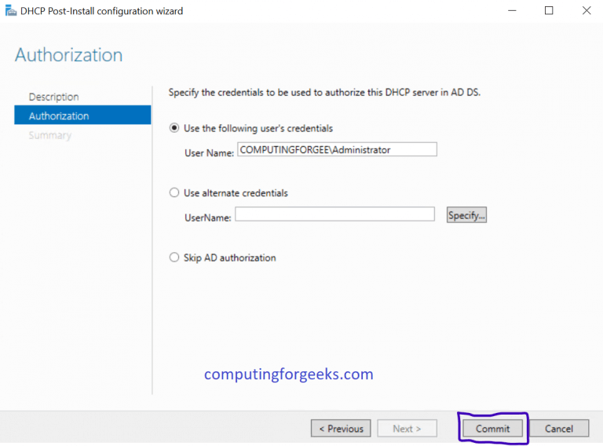

### Configuring DHCP Server

Go back to Server Manager, click on “Tools” and choose “DHCP“. This will open DHCP Configuration Window as shown below.

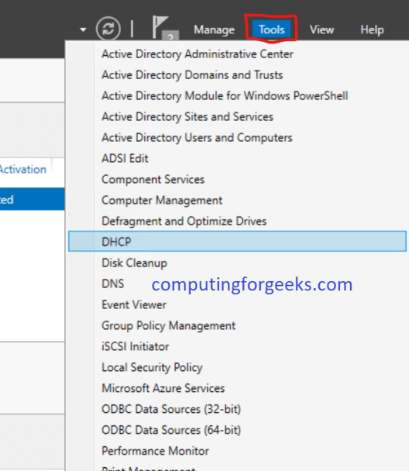

### New Scope

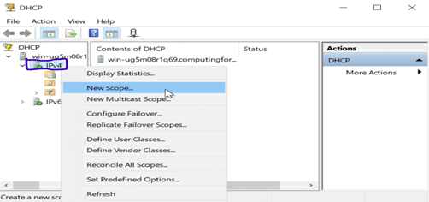On the left pane of the window, click the drop-down as shown above and right-click “IPv4” then choose “New Scope“. A new scope wizard window will pop-up as shown below. Click “Next“

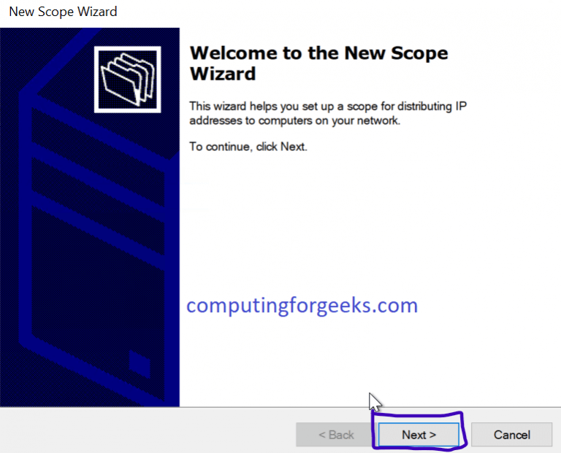

### Name your Scope

Put in a name and Description of this new scope and hit “Next“

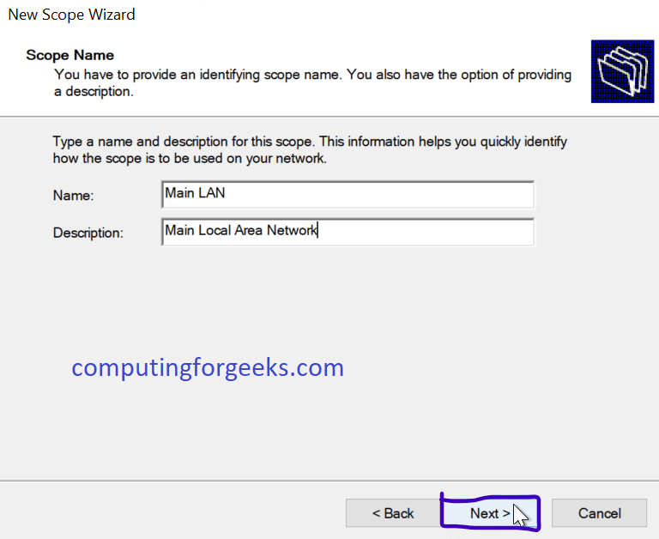

### Input desired IP Address range

Input your start and And IPs, Length and Subnet Mask than hit “Next“

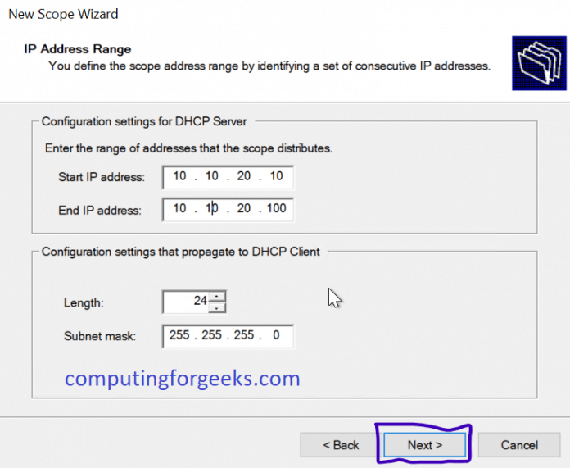

### Set any IPs You would wish to exclude here

If you would like to reserve some IPs in the range for maybe stuff like a printer and other equipment, you can input them at this stage.

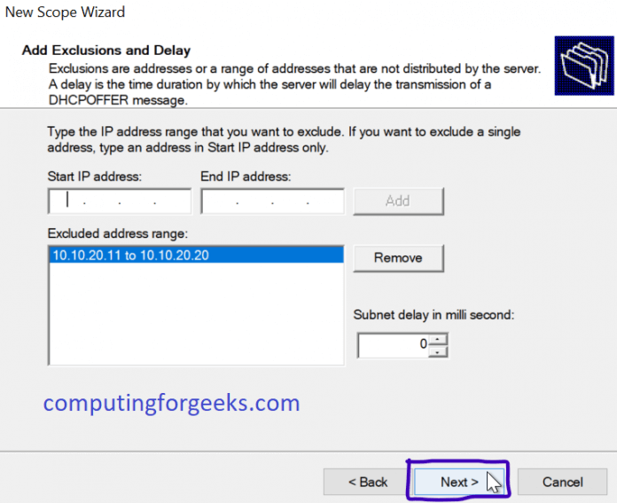

### Lease Duration

Lease duration is the time DHCP Server will give a specific computer or client an IP before changing it or giving it another one when it logs-in again. Set yours and hit “Next“.

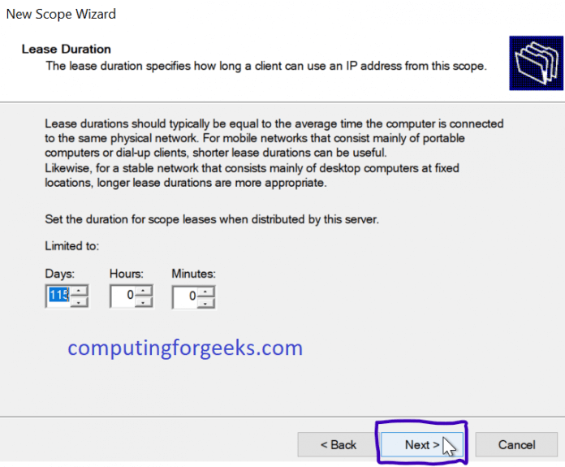

### DHCP Options

On this page, just click “Next” if you are happy with the DHCP Options as described on the page.

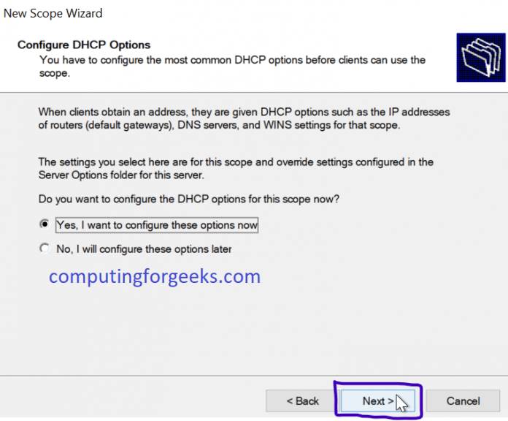

### Input the Default Gateway of the Subnet you gave

On this page, please key in the Default Gateway that the clients will be assigned during lease time. Key in and click “Add” beside it. After that, hit “Next”

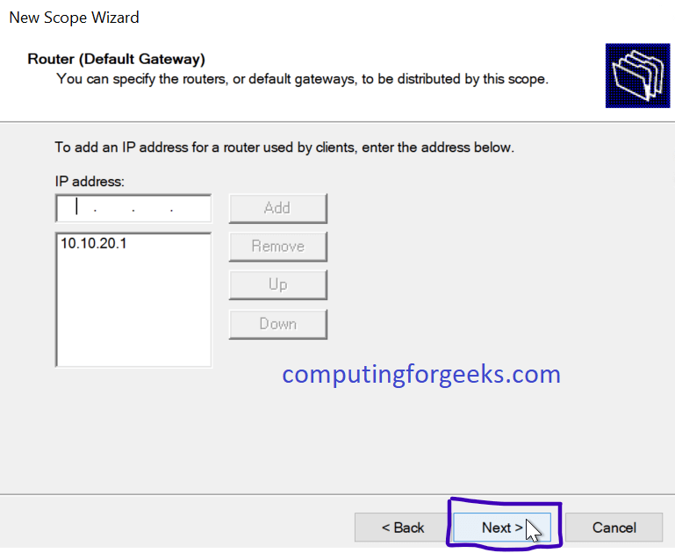

### Key in DNS and Domain Name in your environment

The DNS is very important because it will facilitate the resolution of FQDN to IP Addresses. Key then in and then hit “Next”

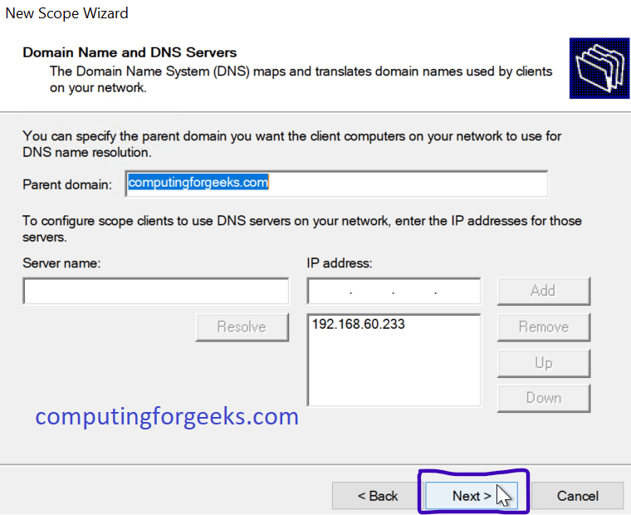

### WINS Server (Optional)

If you would like to use WINS Server in your environment, then input the details in this step and proceed by clicking on “Next“

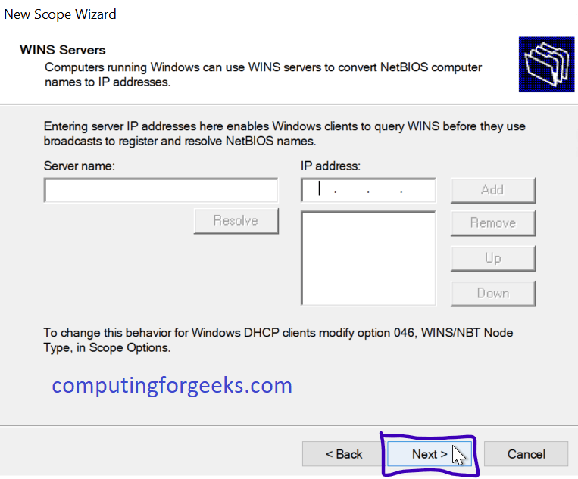

### Activate Scope

On this Step, just click “Next” to activate the scope we have configured. If you would wish to activate it later, choose the second radio option.

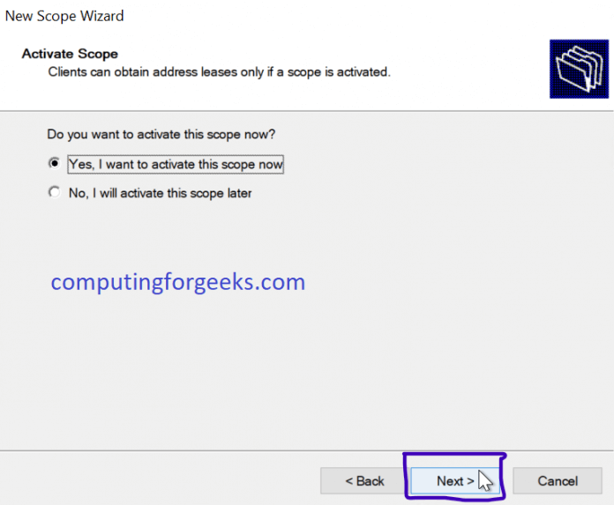

### Finish Scope Configuration

We have finally finished our DHCP Server Configuration. If you have segmented your LAN/Network into VLANS, simply create other scopes as shown above for those VLANS then configure your router to get IPs from the DHCP Server accordingly

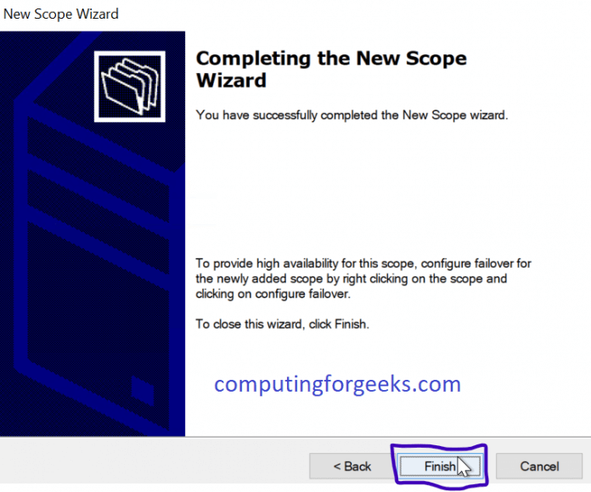

### Confirm your scope is existing as configured

Open up your DHCP Configuration as in Step 11 then check out if your configs are present like below.

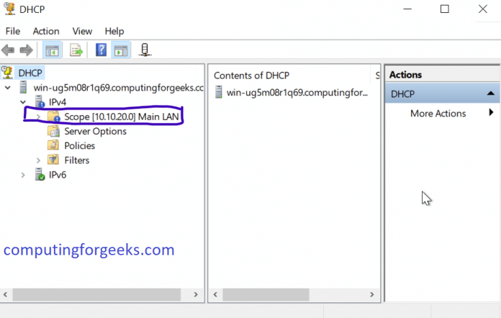

Now that DHCP Server has been configured on our Windows server, the next step is to configure DHCP Client for a Windows machine to obtain an IP Address from DHCP Server.

## Configure Windows Client to Obtain IP from DHCP Server

### Same Network

Make sure the client and the server are on the same network where they can “see” each other. After you have made sure of that part, proceed to configure your windows client to obtain IP Automatically as explained below.

### Network Settings

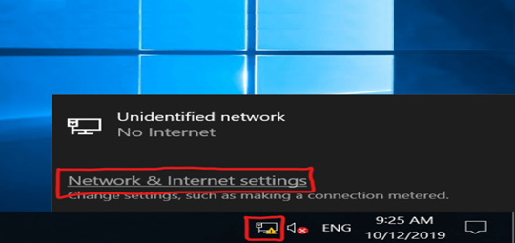Go over to your taskbar, click on your Network icon and choose “Network & Internet Settings” as shown below. A pop-up window will come forth.

On the pop up “Settings” window, choose “Ethernet” on the left pane. After that, choose “Change Adaptor Options” on the right pane below “Related Settings“. A window with your Adaptors will pop up.

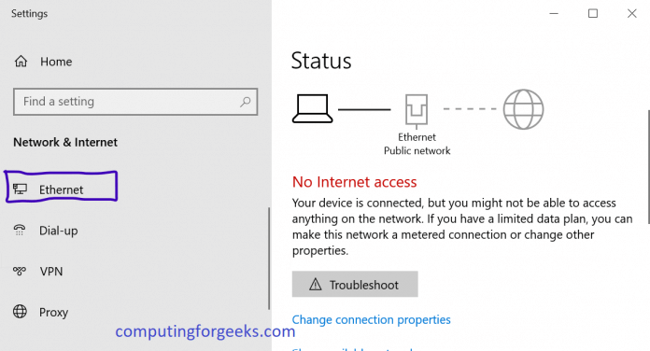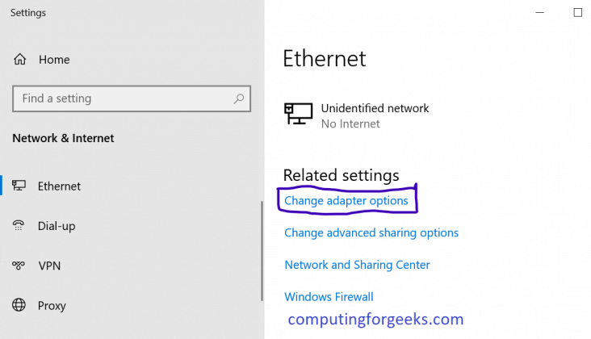

Right-click the right Adaptor and choose “Properties” as shown below. A new window will pop up

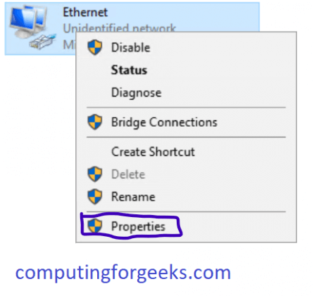

On the new window, click on “Internet Protocol Version 4“, then click on “properties“.

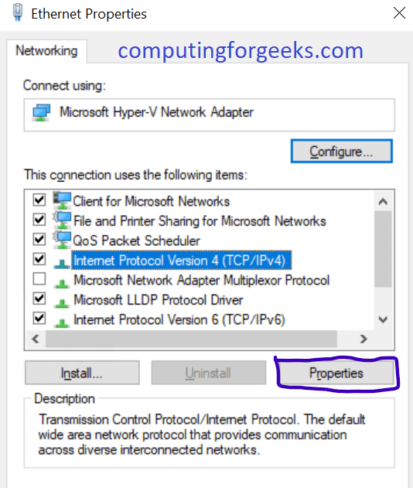

On the new pop up window, leave everything as shown below and click “OK“

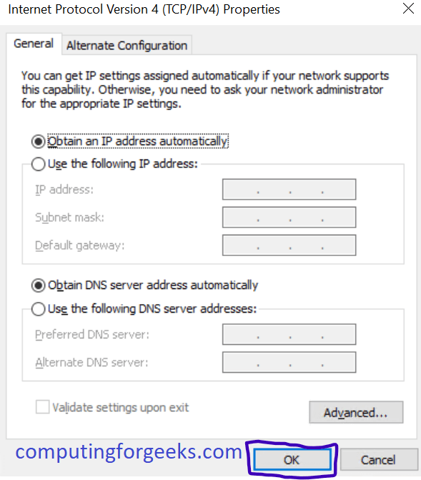

### Command Prompt

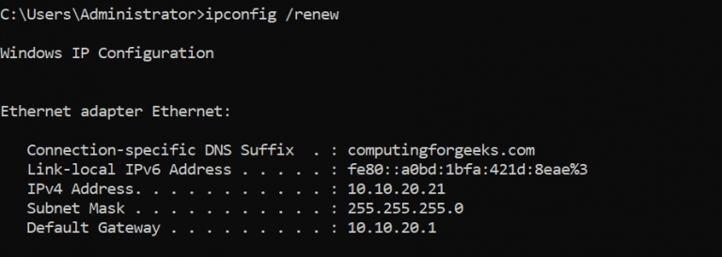You can now go over to Command Prompt and invoke the command shown below to “ask” for a new IP from the DHCP Server.

### Confirm Leases from DHCP Server

Just to make sure everything went well and we are receiving our IPs from the DHCP Server as configured, let us go over and confirm. Open your DHCP Server Manager in the Server and check on the leases.